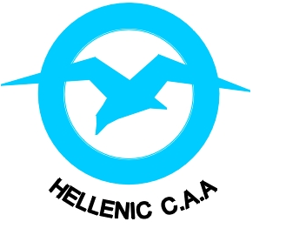
HELLENIC CIVIL AVIATION AUTHORITY
MEMBER OF EASA

INFORMATION BULLETIN PEL IB04/2015
ACAS II Version 7.1 Training, Testing and/or Checking

A. Introduction

- Commission Regulation (EU) No. 1332/2011 of 16 December 2011, which lays down common airspace usage requirements and operating procedures for airborne collision avoidance (ACAS), states that all applicable aircraft shall have collision avoidance logic version 7.1 after 1 December 2015.
- In parallel, FSTDs qualified in accordance with Part-ORA of the EU Aircrew Regulation shall be updated in accordance with mandatory updates to the aircraft types that they represent. However, Part-ORA do not define the required time periods in relation to their aircraft applicability, in which the FSTD updates must be completed.
- The potential exists for the scenario where flight crew personnel, after 1 December 2015, could be operating aircraft with ACAS logic version 7.1, having completed licensing and/or operational training, testing and/or checking on an FSTD equipped with ACAS logic version 7.0.
- The differences between ACAS logic versions 7.0 and 7.1 are small and can be easily quantified.
- The HCAA has assessed the aforementioned scenario, and is satisfied that the associated level of risk from the ACAS version logic differences is acceptable with certain mitigations.
- The purpose of this IB is to detail the expectations of both the FSTD operator and user in providing mitigations to the risk, where this potential exists for this scenario to be realised

B. Scope

- FSTD operators are requested to submit a proposed plan of action to the HCAA, for any FSTDs that are not compliant with ACAS logic version 7.1 as of 1 December 2015, detailing the plan to update the FSTD. Considering the technology and support available for some older FSTDs, it is acknowledged that updates may be difficult. Taking this into account, it is anticipated that all FSTDs will be compliant by 1 December 2016.
- ATOs FSTD users, are expected to detail within the scope of their training approvals, how they will cater for the differences between ACAS logic versions 7.0 and 7.1. A differences brief is acceptable. It is also expected that the organisations SMS will address the risk.

C. Further Information

- HCAA approved ATOs, who use FSTDs where the qualification certificate is issued by EASA, and where the FSTD will not be compliant with ACAS logic version 7.1 by 1 December 2015, should be aware that EASA plan to place a blanket restriction on the FSTD against use of TCAS at the next evaluation after 1 December 2015.
- A detailed guide concerning ACAS logic version 7.1 may be found here

HCAA Personnel Licensing Procedures Manual Issue 02, September 2015 Page 1 of 1

