 |  | ΑΙΤΗΣΗ ΓΙΑ ΠΙΣΤΟΠΟΙΗΣΗ PBN  Application Form for PBN Operational Approval (Airworthiness & Operational Approval Conformance Document)
REFERENCES | ISSUE DATE | TITLE
Reg. (EU) No 965/2012 (As Amended) | 5 October 2012
ICAO Doc 9613 | 2013 | Performance-Based Navigation (PBN) Manual.  (As refered in GM1 SPA.PBN.100 PBN operations)
ICAO Doc 9997 | 2015 | Performance-Based Navigation (PBN) Operational Approval Manual.  (As refered in GM1 SPA.PBN.100 PBN operations)
(EU) No 965/2012 (As Amended)  CAT.IDE.A.345 |  | Communication, navigation and surveillance equipment for operations under IFR or under VFR over routes not navigated by reference to visual landmarks

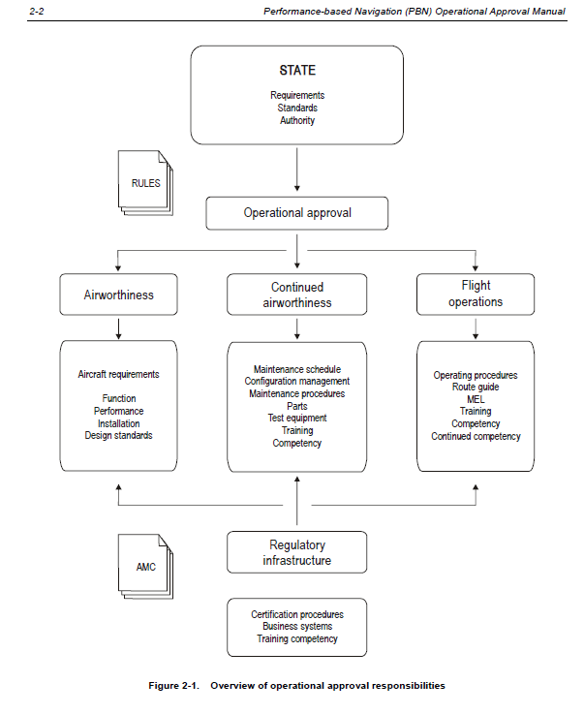

1. Applicant / Operator
Name
Address
Tel |  |  |  |  |  |  | e-mail
Contact person
Number of e-paravolo (*) :

Date of Submission :

2. Aircraft
Aircraft Type
Aircraft S/N |  |  |  |  | Aircraft Registration
3. Applicant request for
RNAV 1; Yes
RNP 4; Yes
RNAV 10 (RNP10) Yes
RNP 1/RNP 2 Yes
RNP APCH — LNAV minima Yes
RNP APCH — LNAV/VNAV minima Yes
RNP APCH — LPV minima Yes
RNP 2 oceanic Yes
PART 1 Airworthiness
- GM1 SPA.PBN.100 PBN operations (d):
“Guidance material for the operational approval of PBN operations can be found in ICAO Doc 9997 Performance-Based Navigation (PBN) Operational Approval Manual”.
-ICAO Doc 9997:
2.3.7 The operational approval assessment must take account of the following:
a) aircraft eligibility and airworthiness compliance (and any limitations, assumptions or specific procedures
considered in the framework of the airworthiness approval must be addressed);
-CAT.IDE.A.345
(f) For PBN operations the aircraft shall meet the airworthiness certification requirements for the appropriate navigation specification.
- Type Design Approval
4.1 The PBN type design approval is reflected in: (*)
Type Certificate |  |  |  | Yes | No
Type Certificate Data sheet |  |  |  | Yes | No
AFM |  |  |  | Yes | No
Supplement Type Certificate |  |  |  | Yes | No
AFM supplement |  |  |  | Yes | No
Service Bulletin |  |  |  | Yes | No
Service Letter |  |  |  | Yes | No
Other (specify) |  |  |  | Yes | No
HCAA Note: Applicant to attach the evidence

4.2 Reference listed in Par. 4.1 Manuals/Docs (*)
RNAV 1; Yes P-RNAV: Yes RNP 4: Yes RNAV 10: Yes A-RNP: Yes
RNP 1/RNP 2: Yes RNP APCH — LNAV minima: Yes RNP APCH — LNAV/VNAV minima : Yes
RNP APCH — LPV minima: Yes RNP 2 oceanic: Yes RNP 10: Yes
FAA AC 20-138 : Yes FAA AC90-100/FAA AC90-100:Yes JAA TGL 10: Yes
AMC 20-4: Yes JAA TGL 2: Yes JAA TGL 3: Yes JAA AMJ 20X2: Yes
AC 20-130A : Yes AC 90-96: Yes AC20-129: Yes AMC 20-27: Yes
AMC 20-28: Yes AC 90-107: Yes RNP 10: Yes AMC 20-12: Yes
FAA 8400.12 : Yes AC 20-138 B: Yes FAA 8400.33: Yes AC90-105: Yes
HCAA Note 1:-Refer to CAT.IDE.A.345
Note 2: -Applicant to Attach the evidence

4.3 RNAV/RNP Navigation Systems on Aircraft (*)
 |  |  | P/N |  |  |  |  |  | No installed
FMS/FMGS Type  HCAA Note: Is the RNAV/RNP equipment which enables the aircraft to be navigated in accordance with appropriate routing instructions along a path defined by waypoints held in an on-board navigation database. |  |  | P/N:…………………. |  |  |  |  |  | One:  Two:  Three:  HCAA Note: Number refers to independent systems.
GNSS stand alone  (for ex.GNS 530) |  |  | P/N:…………………. |  |  |  |  |  | One:  Two:
FMS/FMGS/GNSS Type , Software Version  (for ex. U10…….Boeing 737 a/c) |  |  | S/W version:  …………………………………….
Navigation Data Base Provider |  |  | Navigation Database Type 2 LoA ??  Refer to Navdata provider |  |  |  |  |  | Yes No  HCAA Note: Applicant to attach the evidence
Sensors |  |  | P/N |  |  |  |  |  | No installed
INS/IRS (See HCAA Note 1) |  |  |  |  |  |  |  |  | One:  Two:  Three:
VOR (See HCAA Note 2 and 3) |  |  |  |  |  |  |  |  | One:  Two:
DME (See HCAA Note 3) |  |  |  |  |  |  |  |  | One:  Two:
GPS |  |  |  |  |  |  |  |  | One:  Two:
GPS in accordance with TSO C 129 |  |  |  |  |  |  |  |  | Yes No
HCAA Note:
- Time limit may be applied in the event of unavailability or loss of radio sensor derived automatic position updating, it is permissible to use, for a short period of time, data from an inertial system as the only means of positioning. Period of time has to be agreed with HCAA. Yes No
- Conforms to FM immunity performance standards: ICAO Annex 10, Yes No
- If position determination is exclusively computed based on VOR-DME, the aircraft is not eligible for RNAV 1/RNAV 2 operations. Applicable: Not Applicable:
- Aircraft having approval based on DME/DME cannot execute RNAV Procedures that are based on GNSS only, Annotated on the chart as “RNAV (GNSS)”.

4.5 Maintenance program (*):
The operator should have an established maintenance program that contains all related maintenance requirements prescribed by the manufacturer for PBN related operations.
Yes No

4.6 MEL (*):
The applicant MEL reflects system requirements appropriate for PBN approvals
Yes No
HCAA Note 1 : Sections of Operator MEL regarding PBN items has to be submitted
HCAA Note 2: It is highly advised to present such information in a summarised form together with the other approved RNP and RNAV specifications, as per the matrix below:

Requested Approval | LRN System | GPS | IRS | DME | VOR
RNAV 1 | 1 | 1 | 1 | 2 | 1
RNP 10 | 2 | 2 | 2 | 2 | 2
RNP APCH | 2 | 2 | 2 | 2 | 2

Part 2 Operation
GM1 SPA.PBN.100 PBN operations (d):
“Guidance material for the operational approval of PBN operations can be found in ICAO Doc 9997 Performance-Based Navigation (PBN) Operational Approval Manual”.
ICAO Doc 9997:
2.3.7 The operational approval assessment must take account of the following:
b) operating procedures for the navigation systems used;
c) control of operating procedures (documented in the operations manual);
d) flight crew initial training and competency requirements and continuing competency requirements;
e) dispatch training requirements; and
f) control of navigation database procedures. Where a navigation database is required, operators need
to have documented procedures for the management of such databases. These procedures will define
the sourcing of navigation data from approved suppliers, data validation procedures for navigation
databases and the installation of updates to databases into aircraft so that the databases remain
current with the AIRAC cycle.

6.1 Operation Manual
-a:Does the Operation Manual mention the PBN in the introduction paragraph of the Operations Manual Part A (**)?
Yes No
-b:Is the requested PBN specification listed in the list of applicable Ops Specs within the introduction of the OM-A?
Yes No
HCAA Note: The applicable Ops Spec shall be linked to those aircraft registrations that are eligible for this type of operation.
-c:Does the Organisation established procedures for updating the NAV Database in line with the ARINC cycle (**)?
Yes No
-d:Is there within OM-A 5.1. a description of the required licence, rating(s), qualification/competency (e.g. for routes and aerodromes), experience, training, checking and recent experience for operations personnel to conduct their duties has to be entered.
Yes No
6.2 Does the operating procedures specify:
-a: the equipment to be carried, including its operating limitations and appropriate entries in the MEL(*);
Yes No
-b: flight planning (**);
Yes No
-c: pre-flight procedures (**);
Yes No
-d: procedures prior to airspace entry (**);
Yes No
-e: in-flight procedures (**);
Yes No
-f: post-flight procedures (**);
Yes No
-g: incident reporting (**);
Yes No
-h: specific regional operating procedures (**).
Yes No
j:Where applicable, a minimum equipment list (MEL), adapted from the master minimum equipment list (MMEL), should include items pertinent to operating in PBN operation (*).
Yes No
k:Does the Operation Manual refers to the Equipment: that must be checked “operational” prior entering -Airspace (**) ?:
Yes No
6.3 Training
-a: Does the Organisation established a training programme for the flight crew members involved in these operations (**) ?
Yes No

-b: Does the Organisation established a training syllabi for initial and recurrent training programmes together with other relevant material (**)?
Yes No
-c: Does the PBN-Training correctly integrated (**)?
Yes No
-d: The PBN-Training Module must contain comprehensive instruction of basic knowledge and operational procedures to get familiar with all aspects of operations within PBN-Airspace (**).
Yes No
-e: The PBN Training must define Theoretical training and Practical items
Yes No
6.4 Reporting
Yes No
Documents to be submitted
 |  |  |  |  |  |  |  |  |  |  |  |  |  | Appl. | Not Appl.
Note 1 : (*) Items marked with one asterisk the required evidence must be submitted for each aircraft applying for PBN approval .
Note 2 : (**) Items marked with two asterisks may not be submitted provided that the evidences required have been submitted to HCAA / D2 in a previous application for PBN operational approval of the same type and have not been modified.
7. Applicant Compliance statement
I hereby declare that all documentation and information submitted have been verified and found in compliance with Regulation (EC) No 1139/2018 , its Implementing Rules and all other applicable requirements / procedures.

Continuing Airworthiness Manager  (name) |  |  |  |  |  |  |  | (Signature)  Date
CAMO Quality Manager  (name) |  |  |  |  |  |  |  | (Signature)  Date
Flight Operation Manager  (name) |  |  |  |  |  |  |  | (Signature)  Date
Flight Training Manager  (name) |  |  |  |  |  |  |  | (Signature)  Date

VM Notes:
- FOCA Operations Certification Leaflet P-RNAV
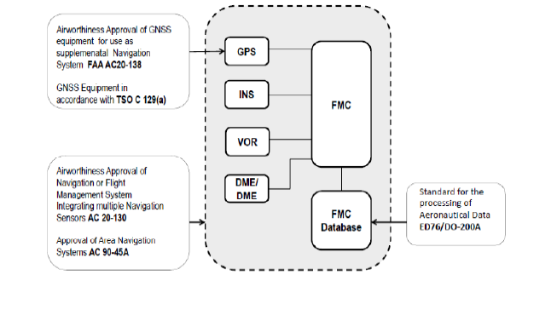

- Note: In the event that the RNAV SID/STAR is based on GNSS but the specific P-RNAV approval for the given aircraft is based on DME/DME or VOR/DME, the crew should not attempt to execute such a procedure.

- RAIM availability respectively the availability of sufficient Satellites for the time where the aircraft is planned to be operated within the P-RNAV covering +/- 15 Minutes of the estimated time where operation takes place therein. RAIM availability prediction services may be provided to users by the air navigation service provider (ANSP), an avionics manufacturer or other entities such as Eurocontrol AUGUR.;

- RNAV 1(Required Functions)
